Ray L Burns, MS CS, MCSE
contactme@RayBurnsResume.com
http://RayBurnsResume.com
(520)979-9500

Computer professional since age 10 seeks opportunity to apply broad-based knowledge, skills and expertise to software development projects in the Tucson area in a friendly, easygoing and flexible work environment.

EXPERIENCE SAMPLER

Software Development
Languages: C#, C++, Java, Visual Basic, Delphi, Pascal, Lisp, SQL, Cobol, HTML, JavaScript, ASP, ASP.NET, many more...
Platforms: Windows, WPF, Silverlight, NET Framework (1.0-4.5), Solaris, Linux, DOS, CP/M, many more...
Assembly: x86, PPC, SPARC, ARM, a29k, 68k, Z80, 6502, many more...
Tools: Visual Studio, Eclipse, Delphi, Access, Visual J++, JBuilder, emacs, many more...
Projects: Device Drivers, Services, Libraries, Compilers, Databases, Automation, Embedded, Components, AI, ...

Hardware Development
Digital logic, CPU design, FPGAs, Interfaces, Networking, Automation, Audio, Spread Spectrum Radio.
Designed and built computer in 7th grade - the instruction set and CPU were my own design.

Networking & Security
Protocols: TCP/IP (DNS, DHCP, WINS, NAT), IPX/SPX, SMTP, IMAP4, RADIUS, SMB, NFS, many more...
Net & OS: Windows (1.0 to 8), Unix (Linux, Solaris, BSD, System V), Netware (1.x to 3.x), many more...
Server Apps: IIS, Apache, Citrix Metaframe, Exchange, SQL Server, sendmail, samba, SFU, many more...
Mgmt Tools: Active Directory, WMI scripting, DFS, SMS, NIS, gsh, automounting, many more...
Networking: Routers (Cisco, Windows, others), Switches, PBX, IP Telephony, Frame Relay, T1, ISDN, DSL, Wireless
Security: Firewalls (Windows, Checkpoint, Cisco), Packet filtering, IPsec, NAT, VPN, L2TP, PPTP, PPP, ...

HONORS
1st in Arizona in Math for Project for Study of Academic Precocity (PSAP).
2nd in USA (top freshman) in American Computer Science League (ACSL) contest.
Top computer student at University High School (admits only top 2% of students).
Scholarships from PSAP & Johns Hopkins to Talent Identification Program at Duke University.
2nd highest WPF user rating in the world on StackOverflow achieved in 6 months and under 500 answers.

EDUCATION & CERTIFICATIONS
Master of Science, Computer Science, University of Arizona, 1994, GPA 4.0 / 4.0.
Bachelor of Science, Computer Engineering, University of Arizona, 1989, GPA 3.7, Magna Cum Laude.
Graduation and 2 Special Certificates, Tucson Institute of Religion, 1989 - 1993.
MCSE, passed all exams on first try with very high scores
Began college at age 14.

MAJOR SOFTWARE PROJECTS

Autonomous Haul Truck

Designed & implemented software architecture for robot haul trucks (85 to 300 ton) used by mines, including:
- Fail-safe and redundancy systems for safe and reliable operation.
- Algorithms for directing and controlling trucks.
- Math, threading, database, and networking libraries used in project.
Robot trucks running well in Australia and South Africa for several years.
Three patents: 6,393,362 - 6,442,456 - 6,799,100

Automated Banking and Healthcare System
Designed & implemented complete system to manage healthcare advocacy, claims and health savings accounts, including:
- Automated web site, phone voice response (IVR), email, print & mail, credit card & check issuing, ACH transfers.
- EDI integration with 30+ banks, brokers, insurance companies, PPOs, PBMs, etc, including Visa & American Express.
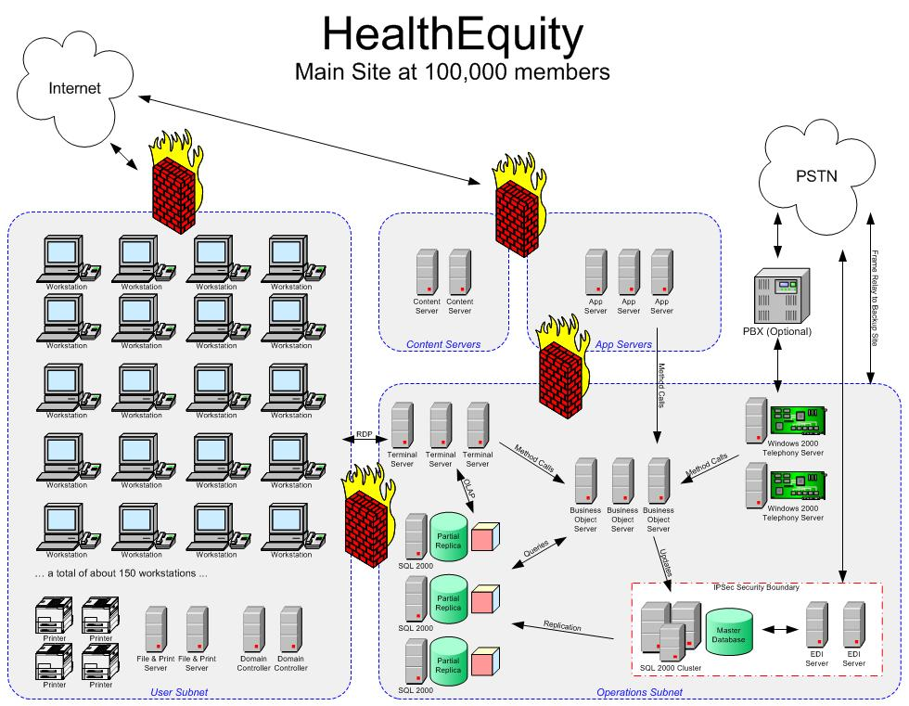
- Automated claims processing and payment, health information lookup.
Used by 100,000+ clients, total transfers so far of over $200 million.

Dispatch Virtual Filesystem
Designed & implemented file system driver for on-the-fly database conversion now used in 100+ large mines around the world.
Clients directly access legacy Unix databases with standard PC tools such as Access and SQL Server.

Embedded Java
Assisted in porting open source Java compiler environment to custom embedded OS, including design of real time garbage collector, compiler and library debugging, graphics library design, and advanced networking libraries.
Also implemented Java interpreter in embedded environment for interactive debugging.

VMerge mail merge
Designed, implemented & marketed mail merge system for Epson QX-10.
Got rave reviews in magazines, hundreds of users.

MAJOR NETWORKING PROJECTS
Planned & implemented complete network infrastructure upgrade:
- Active Directory rollout for 10 offices in 8 countries.
- Custom Windows to Unix account synchronization for worldwide single sign-on.
- DFS, Group Policy, RIS, Certificate Services, and OU delegation, DHCP, DNS, RADIUS, and WINS.
- Global security infrastructure, including Firewall, DMZ, Web Servers, PKI, Auditing, VPN tunnels.
- Upgraded multiple Exchange 5.5 and Unix sendmail domains to Exchange 2000 organization
- Implemented custom synchronization code between sendmail and Exchange, modified sendmail configuration.

WORK EXPERIENCE

Lockheed Martin, 2008-present
Developed software for F-16 fighter pilot training.

HealthEquity, 2002-2008
System architect & chief engineer. Built network, data layer, GUI, Web, IVR, EDI.
Took company from top-of-garage startup to largest non-bank HSA trustee in the world serving 100,000+ clients.

Modular Mining Systems, 1995-2002
Lead analyst on Global IT Infrastructure project.
Lead software engineer on $7 million Autonomous Haul Truck project.
Lead software engineer on Dispatch Virtual Filesystem project.
Company “guru” in dozens of areas.

Computer consultant, 1978-1990, 1992-1995, 2002-2003
Self-Employed computer consultant 16 years. Hundreds of clients. Projects of all sizes.
- Specialized in figuring out how to interface to unusual hardware, software, and operating systems.
Partner in Compuco, a VAR / Vertical systems integrator.
- Integrated diverse applications by writing glue code, file format converters, etc.
- Built custom accounting solutions, which saved companies money and time.
Designed and marketed software for the Epson QX-10, which got very good reviews.
Taught computer architecture class at Pima College.
Revamped, optimized, and added 80x87 floating point support to ZBASIC compiler.
Designed custom hardware / software solution for automotive rebuilders.
CLEARANCES
Secret security clearance.
STRENGTHS
Learning new systems, languages, and standards quickly and completely.
Writing good, clean, fast code in just about any language.
Planning projects and seeing the big picture – getting everything to work well together.
Figuring out how existing programs, operating systems, etc. work and improving on them.
Thrown out of the curve in Computer Architecture, Artificial Intelligence, Theory of Computation,
Programming Languages, and Computational Linguistics classes.

See http://RayBurnsResume.com for more details, including activities and interests.

References available upon request.

